## **CHAPTER 1**

## **INTRODUCTION**

A 2021 World Report on Hearing by the World Health Organization estimates that over 1.5 billion people, or 20 % of the global population, currently experience some degree of hearing loss. This figure is expected to rise to 2.5 billion people by 2050. Out of the 1.5 billion people who experience some degree of hearing loss, 430 million people or 5.5 % of the global population experience moderate or higher levels of hearing loss. A person’s quality of life and daily activities will be affected when such a degree of hearing loss or difficulty goes unaddressed. There are a few factors contributing to the rising cases of hearing loss. One factor is an aging population leading to age-related hearing loss (ARHL). The WHO estimates that 42 % of people aged above 60 years’ experience hearing loss. Hearing difficulties are becoming a greater problem due to the increasingly widespread use of earphones among people and a general habit of listening to music at loud volumes over extended periods ; this is the second major factor contributing to the upward trend in people experiencing or expected to experience hearing loss.

Assistive hearing technologies, such as hearing aid devices, are adopted to restore hearing, improve auditory function and better their quality of life. With the rate of people experiencing hearing loss expected to increase over the next decade, the requirement for hearing aids is becoming more prevalent and demand for hearing aids is expected to grow. A 2021 market report by Fortune Business Insights estimated a global hearing aid market growth of US$6.47 billion in the year 2020 to US$6.67 billion in the year 2021, or US$200 million. Fortune Business Insights further stated that the global hearing aids market is projected to grow from US$6.67 billion in the year 2021 to US$11.02 billion by 2028 at a Compound Annual Growth Rate (CAGR) of 7.4 % in the forecast period, 2021–2028 .

The current process of fitting hearing aids is labor-intensive, slow, and costly. The entire process involves a needs assessment by an audiologist, which includes taking an impression of the patient’s ear canal (ear impression). Fig. 1 represents the entire hearing aid fitting journey. After taking an impression, the audiologist will deliver the silicon ear impression of the patient to a hearing aids manufacturer for 3D scanning. The ear mold would be 3D printed from the scanned 3D data, and the electronics fitted before the manufacturer sends the hearing aid to the audiologist for the patient’s fitting. In the event of a poor fit, the audiologist will take a new impression and deliver the new impression back to the hearing aid manufacturer.

According to a recent survey in the United States, hearing aid styles requiring an ear mold represent more than 60 % of the market share . Hence, it is not uncommon for the fitting of hearing aids to require an ear mold to assist device fixation in the ear canal. A good ear mold will be able to provide an acoustic seal, ensuring good sound delivery by preventing auditory feedback from sound leaks. To construct the ear mold, an impression of the patient’s ear canal and concha (ear impression) will be taken. The traditional method of obtaining an ear impression involves preparing a silicone-based material, which is injected into a patient’s ear, as illustrated in Fig. 2. The current ear impression taking method is to mix a silicone base and catalyst, followed by syringing the mixture into the patient’s ears. This method is ideally performed in specialist clinics and can only be performed by a trained professional, such as an audiologist. At times, ear impression taking may also need to be repeated if the quality of the silicon ear impression is poor.

A poor ear impression is one that fails physical inspection or is contraindicated because of earwax, an active ear infection, or post-surgical wounds. The lack of clinical experience by an audiologist also contributes to a poor ear impression. All these factors require the ear impression process to be repeated on the patient. From a clinical perspective, although this procedure is generally safe, there are known complications such as inflammatory reactions, bruising, and eardrum perforation . Taking an ear impression introduces the risk of the ear impression potentially being trapped in the ear as a foreign body. Surgical removal of ear impressions foreign bodies has been reported several times . Anecdotally, patients have reported discomfort and uncommonly there may be ear canal bruising after the procedure. For patients that suffer from anxiety, the procedure may affect the overall patient experience leading to poorer use of hearing aids. Clearly, a contactless ear canal scanning method would be beneficial.

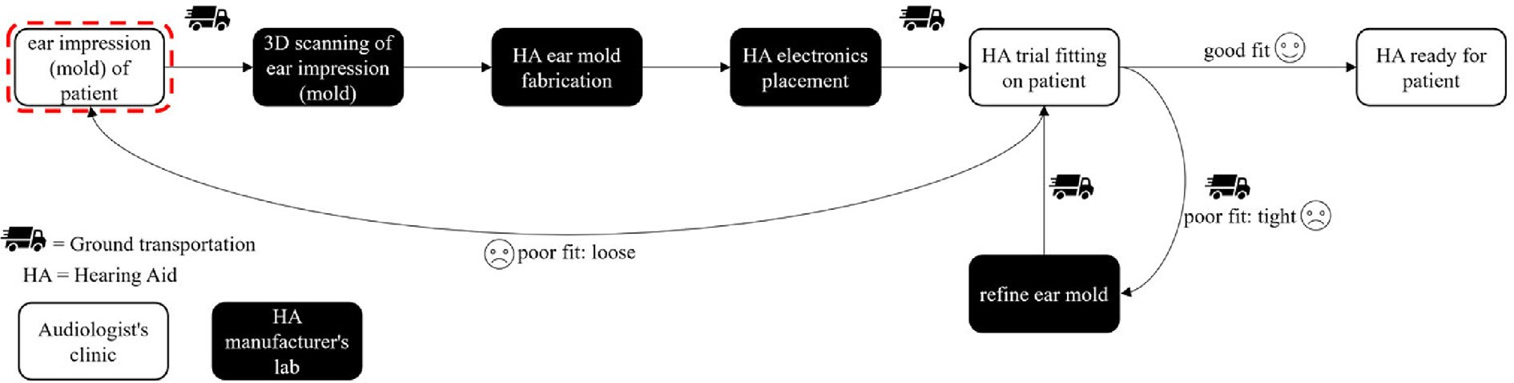

**Fig. 1.** Current hearing aid fitting journey**.**

Alternative mold-less ear impression technologies have been developed. Otoscan, manufactured by Otometrics, is a handheld 3D ear scanning device that makes digital impressions . Otoscan is commercially available, but it still requires a probe to be inserted into the ear canal, which is foreign and may cause discomfort to the patient. There is a steep learning curve in using the device effectively to obtain ear scans. Therefore, Otoscan has developed a training program consisting of 27 different modules with videos and quizzes to support a clinician’s journey to be proficient with the device. The Otoscan system is also relatively expensive and reported to cost US$12,500, with an additional US$1,250 to access the OTO cloud portal, which covers storage, ordering, software updates and maintenance.

Another commercially available handheld 3D scanner is the Artec Space Spider manufactured by Artec 3D. Artec Space Spider utilizes structured light with blue light technology to scan small objects such as keys, coins, or human ears, and reconstruct these objects in 3D. A case study published by Artec 3D reported on its use for scanning the external structure of a normal-sized ear to make ear prostheses for a deformed ear. The Artec Space Spider is delivered with Artec’s studio; the software that enables scans to be processed and 3D rendered. Though effective and reliable, the cost of an Artec Space Spider system is high; currently listed at US$24,800 on Artec 3D’s website .

In 2019, Takahashi et al developed a laser ring gauge device to measure the inner surface profile of the ear canal. Enabled by a laser, light is pulsed through an optical fiber and guided into the entrance of the ear. The digital impression of the ring gauge against the walls of the ear canal is captured by a camera and establishes the path and profile of the ear canal, which is then reconstructed into a 3D model. The entire process does not require impression materials and is essentially contactless.

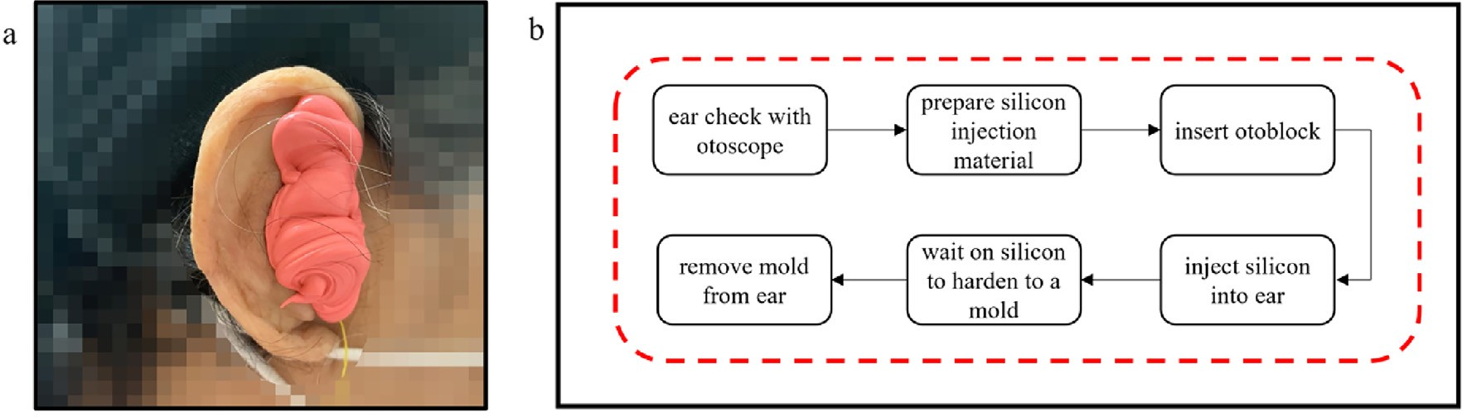

**Fig. 2.** (a) Silicon injected into patient ear; (b) Procedure flow to acquire silicon ear impression of patient.

The research project was completed in 2020, however, this device is not currently commercially available, nor has it been approved for wide clinical use. From interviews with an audiologist, we realized that for a new ear impression methodology to have a real impact, it would need to be inexpensive, easy to use, and reduce patient discomfort.

The central research question that this work addresses is whether external scanners can be adapted to scan the human ear canal accurately and efficiently for hearing aid fitting. We hypothesize that a light-based external-to-the-ear scanner can prove the accuracy to measure large portions of the ear canal directly without physically inserting anything into the ear. Moreover, we suggest that such a system would be less traumatic for the patient, faster, more economical, and be environmentally more sustainable. To test these claims, we compared three of the most common lightbased scanning technologies in terms of technical performance and functionality of the system and optimized one of them for direct ear canal scans.

**1.1 Objectives**

* To extend 3D printing as a tool to validate a digital methodology of taking ear canal impressions for hearing aids.
* A comparison of different contact- less scanning technologies.
* To show that this method of scanning ears directly, without taking an impression, reduces ground transportation and therefore lowers the global warming potential.

**CHAPTER 2**

**LITERATURE SURVEY**

**2.1 Summary of prior works**

# 2.1.1 “Hearing aids system for impaired peoples”

**Description:**

 Traditional analog hearing aids are similar to a simple radio. They can be tuned and adjusted for volume, bass and treble. But hearing loss is not just a technical loss of volume. Rather, hearing deficiency can increase sensitivity and reduce tolerance to certain sounds while diminishing sensitivity to others. For instance, digital technology can tell the difference between speech and background noise, allowing one in while filtering out the other. Approximately 10% of the world's population suffers from some type of hearing loss, yet only a small percentage of this statistic use a hearing aid. The stigma associated with wearing a hearing aid, customer dissatisfaction with hearing aid performance, and the cost associated with a high performance solution are all causes of low market penetration.

# 2.1.2 “Hearing Preservation in Cochlear Implantation”

## **Description:**

Preservation of residual acoustic hearing has emerged as an important concept for those individuals undergoing cochlear implantation with residual low frequency hearing. Acoustic plus electric speech processing improves hearing outcomes in quiet, enables melody recognition, preserves spatial hearing if there is acoustic hearing in both ears and significantly improves hearing in noise. The development of our experience with acoustic plus electric processing is reviewed along with clinical trials and patient outcomes that our team has documented over the past twenty years.

# 2.1.3 “Cochlear implant spectral bandwidth for optimizing electric and acoustic stimulation”

**Description:**

# Cochlear implantation with acoustic hearing preservation is becoming increasingly prevalent allowing cochlear implant (CI) users to combine electric and acoustic stimulation (EAS) in the implanted ears. Despite a growing EAS population, our field does not have definitive guidance regarding EAS technology optimization and the majority of previous studies investigating hearing aid (HA) and cochlear implant (CI) programming for EAS listeners have been mixed. Thus, the purpose of this exploratory study was to explore the effects of various EAS crossover frequencies—defined as the low-frequency (LF) CI cutoff—relative to the underlying spiral ganglion (SG) characteristic frequency associated with the most distal or apical electrode in the array.

# 2.1.4 “A new paradigm of hearing loss and preservation with cochlear implants: Learnings from fundamental studies and clinical research”

**Description:**

The understanding of causes evolved over the course of the program, leading to an increased appreciation of the role of the biological response in post-implant hearing loss. A systematic approach was developed which mapped the cochlear implant journey along a timeline that considers all events in an individual's hearing history. By evaluating the available data in this context, rather than by discrete hypothesis testing, causative and associated factors may be more readily detected. This approach presents opportunities for more effective research management and may aid in identifying new prospects for intervention.

# 2.1.5 ‘‘Cochlear implant imaging in the mouse and guinea pig using light-sheet microscopy.”

**Description:**

# Postmortem examination of the cochlea with a cochlear implant in the scala tympani presents several challenges. It is technologically difficult to section a cochlea with an implant due to the presence of its wires and metal components that are adjacent to the membranous and bony tissues of the cochlea. These metal components damage traditional steel blades of a microtome in celloidin, paraffin or frozen embedded tissues. However, plastic embedded implanted cochleas have been successfully sectioned using specialized methods (Irving et al., 2013). An alternative non-destructive method is to optically section a chemically cleared cochlea using light-sheet microscopy, which we will describe in this publication. However, since this method uses a light-sheet to section the cochlea the opaque and reflective metal components of the implant results in some artifacts in the 2D optical sections. The best image quality using light-sheet fluorescent microscopy is when the implant is removed prior to imaging.

# 2.1.6 “Novel Impedance Measures as Biomarker for Intracochlear Fibrosis’’

**Description:**

The present study explores a new impedance measurement option recently included into the cochlear-implant programming software and aims to contribute to a more solid basis for the clinical use of impedance measures as a biomarker for fibrous tissue formation. Twenty adult CI-recipients were followed from surgery until 1 year after implantation by means of Electrode Voltage Telemetry (EVT), also called Electric Field Imaging or TransImpedance-Matrix measurement, and a 4-point technique for probing the voltage between adjacent electrode contacts. The data were compared to the electrode location derived from [computed tomography](https://www.sciencedirect.com/topics/neuroscience/computed-tomography), and to the device usage log. Using our impedance model for electrical stimulation of the cochlea, the polarization impedance related the electrode–tissue interface was determined, and the bulk impedance (access resistance) was split into a near-field and a far-field component. On average, the polarization impedance increased abruptly after surgery, indicating a strong passivation of the electrode contacts before cochlear-implant initiation. Its initial rise resolved almost completely soon after device switchon (2–4 weeks).

**CHAPTER 3**

**MATERIALS AND METHODS**

**Methodology of proposed work**

* 1. **3.1 3D Scanning Technologies**

Three contactless 3D scanning technologies are evaluated for their effectiveness in ear scanning. These contactless 3D scanning technologies are tested with readily available commercial and professional packages used to 3D digitize a physical object. A 3D model of a patient’s ear impression, scanned from a silicon earmold, was 3D printed as the control ear as shown in Fig. 3(c). The 3D control ear model was printed on a fused deposition modeling (FDM) printer with white polylactic acid (PLA) filament. The purpose of this 3D printed control ear is to validate the three contactless 3D scanning technologies on their ability to obtain outer ear scans. Fig. 3 shows the model of the 3D printed control ear, the model of the 3D printed ear without the enclosing sides for the ear canal structure visualiza- tion, and the actual 3D printed control ear.

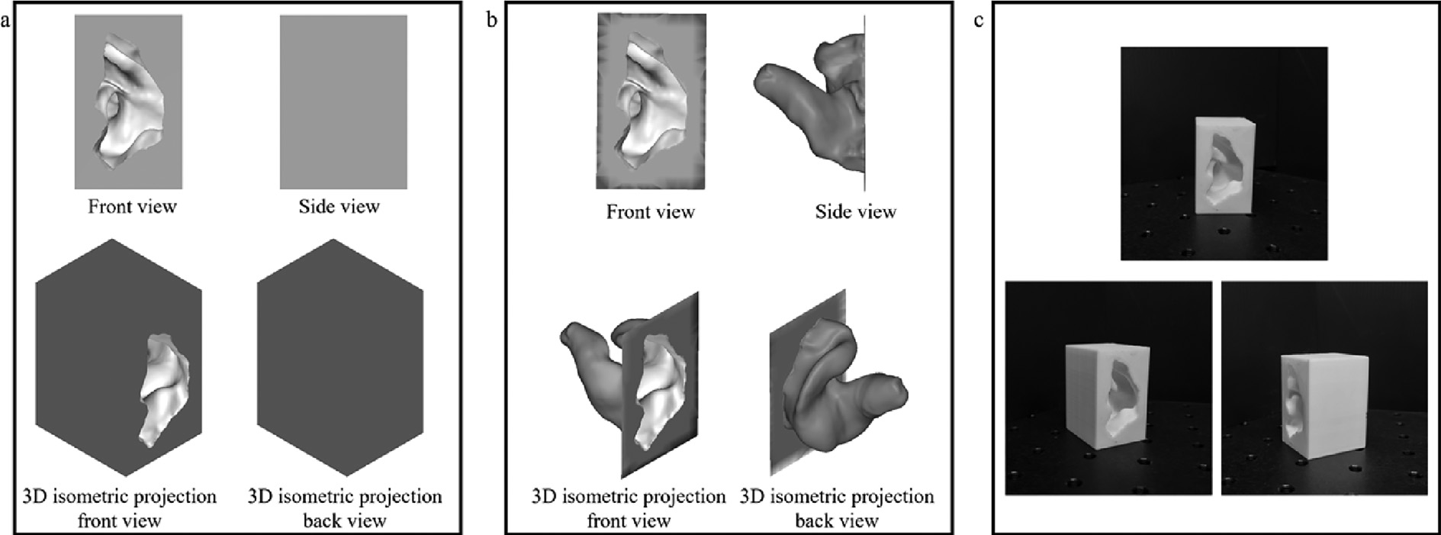

Fig. 3.(a) Control ear’s 3D model;

(b) Control ear’s 3D model without enclosure;

(c) 3D printed ear;

* + 1. **3.2 Photogrammetry**

The photogrammetry method uses a camera handheld or on a tri- pod, which is used to take images of the object of interest. To model images from 2D to 3D, a structure-from-motion (SfM) techniqueis used to compute 3D point cloud information of the object’s surface. It is a two-step process, where identifiable points in each image are matched and the position of the camera calculated, fol- lowed by plotting of the points in a 3D spacereconstructract a point cloud of the object captured. The primary principle underpin- ning this technology is triangulation. To test and validate this tech- nology, a testbed consisting of a high-resolution Digital Single Lens Reflex (DSLR) and light-emitting diode based (LED) ring light was set up to scan the 3D printed control ear, as illustrated in Fig. 4(a).

A series of photos of the control ear were taken at different angles along the vertical and horizontal plane with the control ear being the axis of rotation, totaling to 69 images captured. These are then uploaded into Autodesk ReCap Photo’s photogrammetry pro- gram for 3D reconstruction. An educational license of Autodesk ReCap has a limit of 100 images for each scan, which is sufficient for small objects such as the 3D printed control ear. The final 3D model can be exported in mesh or point cloud formats. Fig. 4(b) shows the workflow of the photogrammetry scanner, including the software used to obtain the final 3D model of the scanned control ear. As Autodesk ReCap Photo used cloud-processing, which was running on an educational license, a lower priority queue was pro- vided for the license. Thus, in this study, photogrammetry scans were typically received between 24 and 48 h after uploading the photographs. As Autodesk Recap’s photogrammetry software has no real-world geometric calibration, the point cloud data must be scaled. This can be performed within Autodesk Recap with their scaling tool, or the unscaled point cloud data can be aligned and scaled to the control ear simultaneously on CloudCompare. The latter was performed on the photogrammetry-scanned model for post- processing.

The Canon EOS 600D was utilized for the testbed and is no longer actively sold by Canon. However, listed on Canon’s website is an equivalent or better DSLR, the EOS 850D 24.1MP high- resolution camera priced at approximately US$950. Including a US$10 LED ring light to improve canal illuminance during capturing, the estimated total cost of the set-up is approximately US$960, with the software running on an educational license. Autodesk offers a subscription-based pricing model of Autodesk ReCap at US$340 per year.

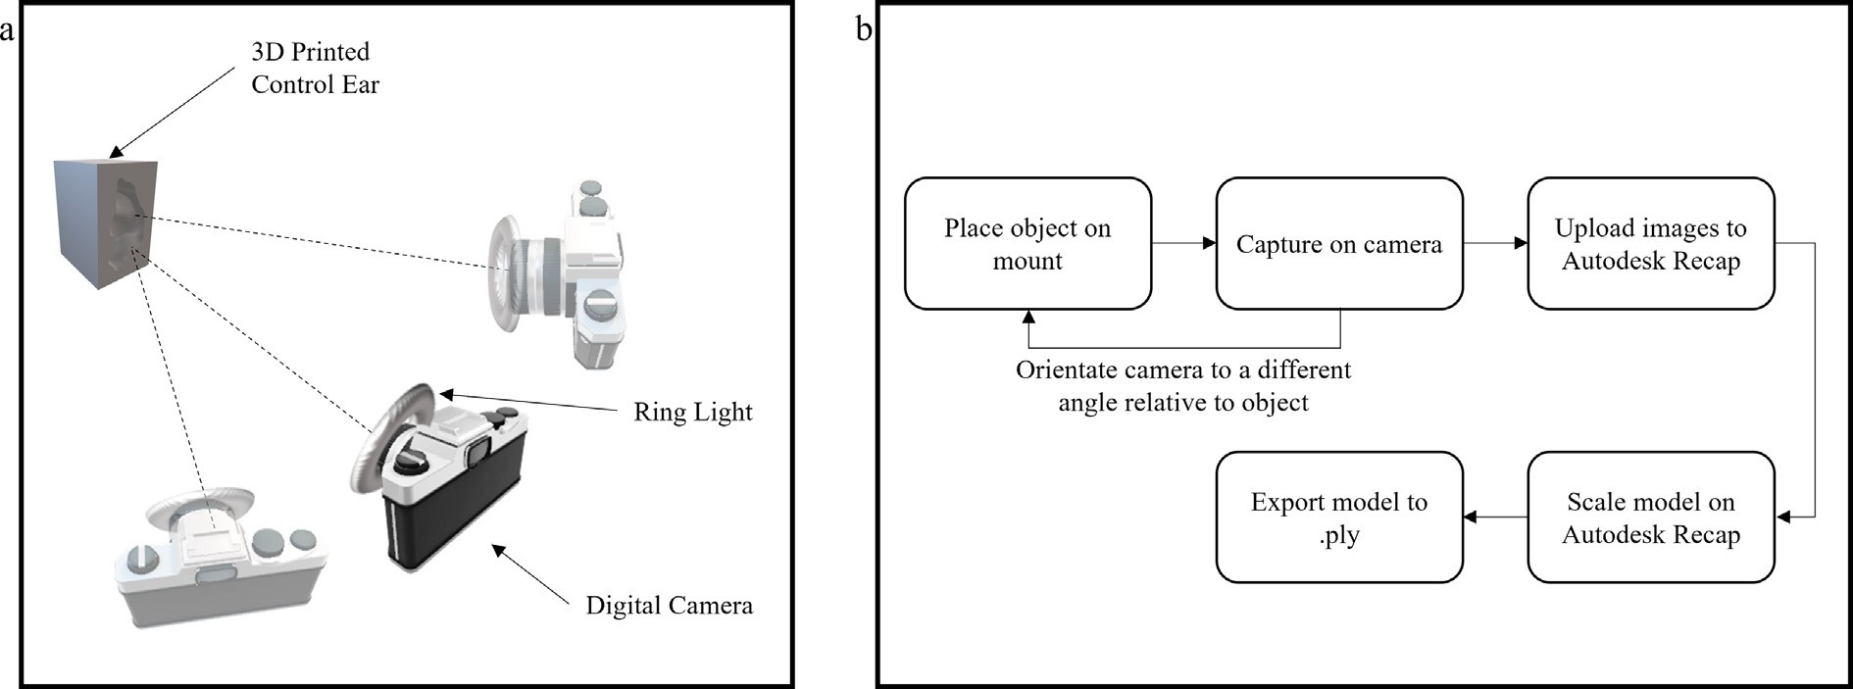

Fig. 4. (a) Illustrated set up for photogrammetry;

(b) Workflow to obtain 3D model from photogrammetry

* + 1. **3.3 Structured light scanning**

The structured light scanning (SLS) method uses one or more cameras to capture the 2D images of structured-light patterns projected onto a scene. The primary principle underpinning this technology is triangulation. On a plain scene with no protrusion, such as a flat surface, the image captured is similar to the structured-light patterns projected. If there is a 3D object in the scene, there will be distortions in the structured-light patterns mon- itored in the captured image. The profile of the object in the scene will be extracted from the distortions captured, processed, and dig- itally reconstructed with algorithms. An established technology, it is utilized by Artec 3D for its Artec Space Spider system.

×

To test and val- idate this technology, we built a set-up to scan the 3D printed control ear. Illustrated in Fig. 5(a), the set-up consists of two sets of five- megapixel universal serial bus (USB) complementary metal oxide semiconductor (CMOS) cameras with 12 mm lenses and a digital light processing (DLP) native 854 480 resolution projector. FlexS- can3D [21], a commercially available structured light scanning soft- ware developed by Polyga, was connected to the SLS scanner for capturing, processing, and constructing the 3D model. The FlexScan3D software was installed on a laptop running an on Intel i7-1165G7 processor, with 16 GB physical memory and a MX4502 GB graphics card.

The 3D printed control ear was placed on a flat surface and rotated along the z-axis to capture various angles of the ear, and putty was used to hold the 3D printed control ear at var- ious angles in the yz-plane. A total of 50 scawerewas captured and processed. The structured light scanner’s software has good auto- alignment and finalization tools, and therefore this method did not require significant manual post-processing. It took approximately 28 min to scan, process and align 50 individual scans to construct a 3D model of the scanned control ear. The 3D model would be exported in mesh or point cloud formats. Fig. 5(b) shows the work- flow of the SLS scanner and software to obtain the final 3D model of the scanned control ear.

The cost of the set-up was approximately US $1,075, where the projector, USB cameras and lenses are commercial off-the-shelf items that can be found readily and are relatively low in cost. Polyga offers a subscription-based pricing model of FlexScan3D at US$500 per year.

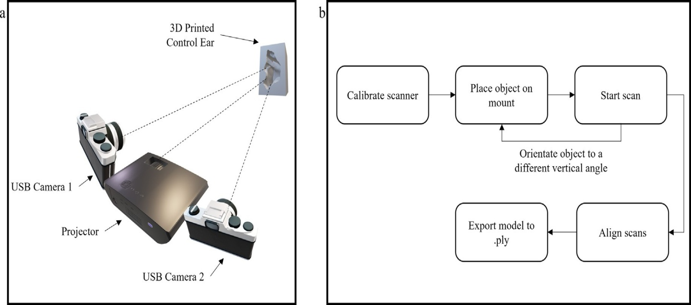**Fig. 5.** (a) Illustrated set up for structured light scanning;

(b) Workflow to obtain 3D model from structured light scanning.

* + 1. **3.4 Laser line scanning**

The laser line scanning method measures the distance between the laser source and the object, and the laser beam is rastered across the surface of an object. Similar to photogrammetry and SLS, the primary principle for this technology is triangulation. Shown in Fig. 6(a), the Matter and Form laser line scanner was set up with their software as the test bed. The 3D printed control ear was placed on the scanner’s bed, which rotates along the z- axis to capture lines scans at various angles of the ear. As with the SLS method, putty was used to hold the 3D printed control ear at various angles in the yz-plane. A total of 50 scans was cap- tured and processed.

The final 3D model was exported in point cloud format. Fig. 6(b) shows the workflow of the laser scanner and software to obtain the final 3D model of the scanned ear. The software packaged with the laser scanner, MFStudio, has an alignment tool. However, the alignment tool displayed poor alignment results. As such, manual alignment was required to merge all the scans. MFStudio does not facilitate such manual alignment; thus, each model must be exported in a point cloud for- mat and imported into a secondary software for alignment.

After manual alignment, the models can be merged into a single model and exported in a point cloud format for evaluation. The secondary software is CloudCompare, a 3D cloud and mesh processing software. Each modwas el translated, rotated, and aligned with the first scan at 0 deg along the xz- plane. This additional step was laborious as it required four points to be aligned on the refer- ence model. Every scan from the laser line scanner had to go through this alignment step, ultimately taking up to 1.5 min per scan. The cost of the set-up is US$650, with the current price for the scanner and software package listed at US$650.

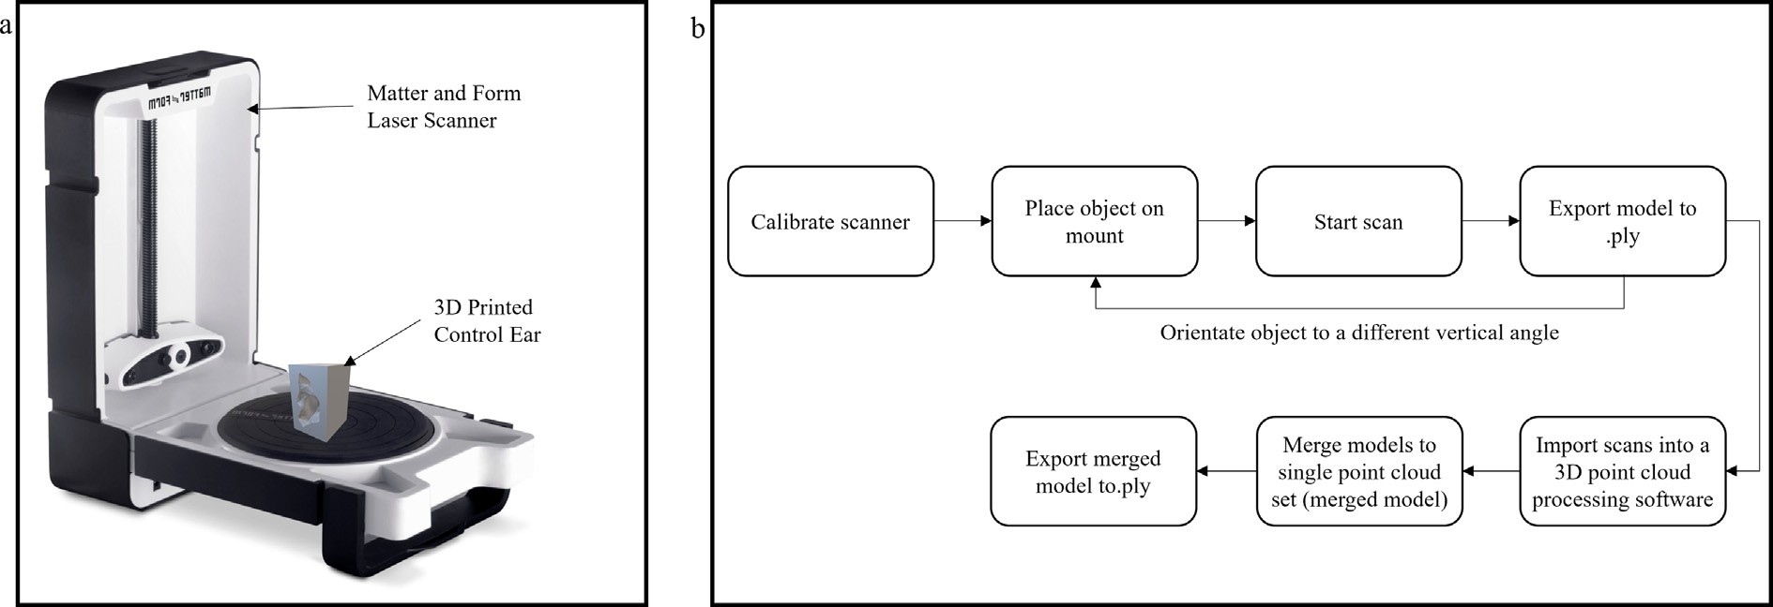

Fig. 6. (a) Illustrated set up for laser line scanning;

(b) Workflow to obtain 3D model from laser line scanning

* 1. **3.5 Environmental impact assessment from ear mold ground transportation**

The current ear impression process requires multiple trips to send the earmolds between an audiologist’s clinic and the hearing aid’s manufacturing lab for scanning and fabrication. As illustrated in Fig. 1, a good quality impression that fits well in the patient’s ear would just require two ground transportations. However, a poor quality impression may require multiple fittings could require up to four ground trips between the audiologist’s clinic and the hearing aid manufacturer’s lab.

To facilitate the potential change in environmental impact on the ground transportation of earmolds, we assume a net weight of 50 g for each set of earmolds and a one-way average distance of 16.8 km between the clinic to the hearing aid manufac- turer’s lab on a small lorry transport with a maximum 3.3 tonnes payload. This 16.8 km average distance was calculated based on Changi General Hospital’s location to the five different hearing aid manufacturers it works with and is realistic for Singapore, how- ever, it may be substantially longer in larger countries.

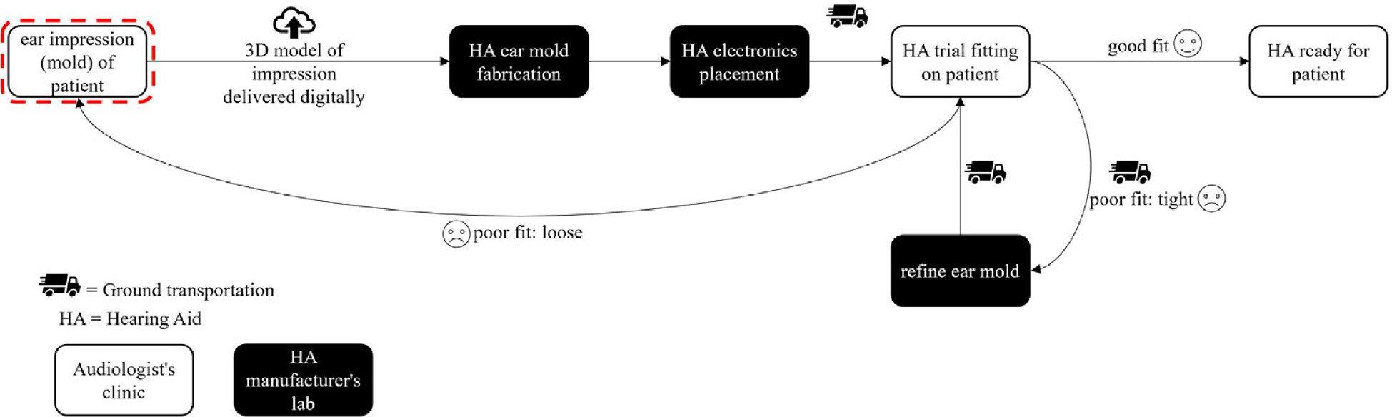

**Fig. 7.** Post-optimised hearing aid fitting journey

The potential environmental impact, assessed with regard to the global warming potential (GWP), was ascertained by comparing the current hearing aid fitting journey and the post-optimised hearing aid fitting journey, as shown in Fig. 7, using the openLCA software with the European refer- ence Life Cycle Database (ELCD) and the ecoinvent Life Cycle Impact Assessment (LCIA) database based on a method pro- posed at the Intergovernmental Panel on Climate Change (IPCC) 2013.

**CHAPTER 4**

**RESULTS AND DISCUSSIONS**

* 1. **4.1 Comparing the 3D scanning technologies**

The results from the 3D scanning technologies are listed in Table 1 and Table 2, and the resulting 3D models from each scan- ning technology are shown in Fig. 8. The capability of the technol- ogy for ear impression application is determined by four technicalmetrics: 1) the depth of scan into the ear canal, 2) the distance deviation of the scan against the control ear, 3) the surface and volume deviation of the scan against the control ear and 4) the time it takes to complete a full scan. Functional metrics of the technolo- gies are also considered. The software Cloud Compare was utilized to compare the scanned point cloud against the control ear’s point cloud data. The point cloud data was imported into Cloud Compare for all three scanning technologies to enable a point cloud to point cloud comparison of the depth of the scan, volume, and surface computation against the 3D model of the control ear.

It is important to note that the three 3D scanning technologies were validated by scanning an FDM printed 3D model of the control ear; as such, dimensional tolerances of up to ± 0.2 mm were expected. As all three scanning technologies were tested on the same 3D printed control ear, we have assumed that random errors caused by the tolerance are equal and a fair comparison of the three 3D scanning technologies can be made. To prepare the com- parison, the scanned 3D models obtained from the 3D scanning technologies were aligned to the 3D model of the control ear and the enclosure surrounding the ear canal structure was sliced out. A cross-section of the canal was extracted from each scanned model and the control ear’s model in-canal volume and surface deviation were computed. The 3D model of the controlled ear’s canal measured a volume of 7,391.693 mm3, a surface of 1,451.000 mm2 and a depth of 30.238 mm from the auricle.

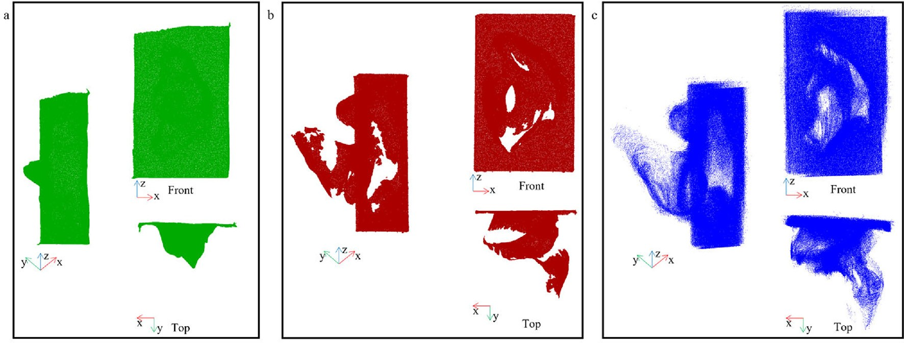A scoring matrix was used to determine the most suitable technology for scanning ear canals for hearing aid fitting. Scores were awarded based on technical performance, functionality, and the usability of the system. The results of the comparison of each technology’s 3D model in point cloud against the control ear’s 3D model in point cloud format can be seen in Table 2. A score between one and three was given to each technology, with the most suited technology for the metric assigned a score of three and the worst assigned a score of one. The technology with the highest total score receives the first rank and the technology with the lowest tabulated score receives the third rank. Thus, the first- ranked technology should be the best suited to contactless hearing aid fitting applications.

Fig. 8. (a) Photogrammetry scanned 3D model;

(b) Structured light scanned 3D model; (c) Laser line scanned 3D model.

Photogrammetry scored well under the criteria of functionality of the system and was the easiest to use. There was no need to cal- ibrate with Autodesk ReCap and taking pictures at various angles with the object in the center of the field of view was simple with near-zero training expected to perform such a task. Autodesk Recap also provides basic slicing, transformation, and scaling tools for post-processing of the generated 3D model scan. However, the results were the least favorable on the effectiveness of this method with poor 3D digitization and measurement of the control ear.

Structured light and laser line scanning technologies scored closely on effectiveness; however, a clearer distinction was seen in terms of the functionality and application requirement metrics, with structured light scanning taking the lead. The laser line 3D model scan was able to produce a visually well-represented structure of the control ear, however, we observed a high level of noise with a root mean square value of 0.77 mm in the final point cloud data set against 0.3 mm computed for the structured light 3D model.

This noise can be attributed to the poor manual alignment of the 11 scans and the glossy surface from the material of the 3D printed control ear. In addition, the built-in post-processing tool lacked the function to manually align scan-to-scan point cloud data, and the auto-alignment function was rough and could not be utilized. This meant substantial post-processing work was required to obtain a final 3D model, and this was extremely laborious, time- consuming, and likely to produce models of poor quality.

With the laser line scanner, the subject must remain very still during the scan, where a slight movement will result in an inaccurate and poor-quality 3D model scan. The extended time required to take one scan with the laser line scanner contributed to its lower cumulative score. The structured light scanner also produced a well-represented structure of the control ear with a high score on the effectiveness metrics. The structured light scanner software had the highest score for functionality because the auto-alignment tool significantly shortened the time to finalize the 3D model due to minimal manual alignment.

Considering, our ultimate objective of low-cost contactless scanning human ears with minimal train- ing, the structured light scanning technology was determined to be the most suitable technology for the proposed application. It could measure large portions of the ear canal and although the scanning time is rather long, it can be substantially reduced by using lower resolution images and higher performance processing computer hardware.

* 1. **4.2 Comparing the potential environmental impact**

The GWP of greenhouse gases emitted from ground transportation in the hearing aid fitting process is analyzed and shown in Fig. 9. An optimized process, which relies on contactless 3D scans, will lead to a lower frequency of required ground transportation between the clinic and the hearing aid’s manufacturing lab. More- over, a successful first-time hearing aid fitting will reduce the GWP by 50 %, a one-time loose fitting will reduce the GWP by 50 %, and a one-time tight fitting will reduce the GWP by 25 %. Note, these GWPs are underestimates because the distances travelled are relatively short due to Singapore’s clinics and hearing aid manufacturing labs being relatively close. In larger countries, the CO2 savings are likely to be greater. Moreover, this study does not consider the distances travelled by patients each time they need to have their hearing aid fitted or adjusted, which may also be reduced by an accurate ear scanning technology.

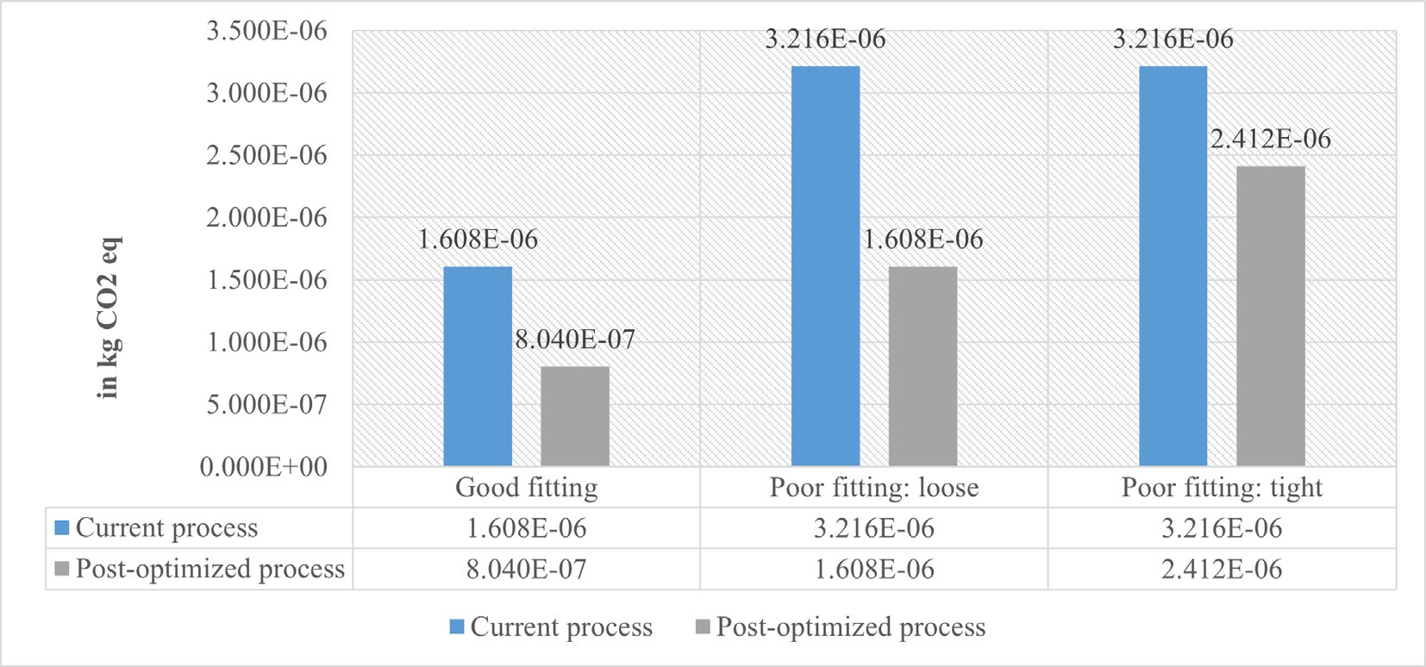

**Fig. 9**. Contribution to global warming (GWP100a) comparison between current and post-optimized hearing aid fitting process

**CHAPTER 5**

**CONCLUSION**

* + 1. **5.1 Conclusion of proposed work**

This study aimed to assess whether external scanners can be adapted to scan the human ear canals accurately and efficiently for hearing aid fitting. To test the capability of the different methods, a 3D printed model of a real human ear was scanned by three scanning methods: (1) photogrammetry, (2) structured light, and (3) laser line scanning. Each method’s ability to scan the human ear canal accurately and efficiently for hearing aid fitting was critically assessed using design matrices. Structured light scanning was determined to be the best suited technology for developing an optimized digital methodology that can be used by an audiologist to directly measure large portions of the ear canal without physically contacting the ear. This method enables digital impressions of the ear to be taken instead of first taking a physical silicone impression and subsequently scanning it. Hence, it reduces the clinical risk and discomfort to the patient. In addition, directly scanning the ear may reduce CO2 emissions as the frequency of ground transportation between a clinic and the hearing aid manufacturer can be substantially optimized. In the long term, external scanning methodologies will make the hearing aid fitting process more economical and environmentally sustainable. This study sets the foundation to develop a structured light scanning prototype that is optimized for an audiologist to scan human ears accurately, efficiently, sustainably, and inexpensively.